pertemuan_6.R
r4057270
2026-10-05
# Tipe data
#Numeric
print("Numeric")
## [1] "Numeric"
a <- 10.5
class(a)
## [1] "numeric"
print("Integer")
## [1] "Integer"
b <-1000L
class(b)
## [1] "integer"
print("character")
## [1] "character"
c <- "Nama saya adalah Miky"
class(c)
## [1] "character"
print("complex")
## [1] "complex"
d <- 9i + 3
class(d)
## [1] "complex"
print("Boolean")
## [1] "Boolean"
e <- TRUE
class(e)
## [1] "logical"
#Struktur Data
buah <- c("Anggur", "Apple", "Mangga")
buah #Vector
## [1] "Anggur" "Apple" "Mangga"
list_buah <- list("Druian", "Mangga", 10, 20)
list_buah #Data List
## [[1]]
## [1] "Druian"
##
## [[2]]
## [1] "Mangga"
##
## [[3]]
## [1] 10
##
## [[4]]
## [1] 20
matrix_angka <- matrix(c(1,2,3,4,5,6), nrow = 3, ncol= 22)
matrix_angka
## [,1] [,2] [,3] [,4] [,5] [,6] [,7] [,8] [,9] [,10] [,11] [,12] [,13] [,14]
## [1,] 1 4 1 4 1 4 1 4 1 4 1 4 1 4
## [2,] 2 5 2 5 2 5 2 5 2 5 2 5 2 5
## [3,] 3 6 3 6 3 6 3 6 3 6 3 6 3 6
## [,15] [,16] [,17] [,18] [,19] [,20] [,21] [,22]
## [1,] 1 4 1 4 1 4 1 4
## [2,] 2 5 2 5 2 5 2 5
## [3,] 3 6 3 6 3 6 3 6
#Data frame (DF)
statistik_game_RPG <- data.frame(
stat = c("Power", "Mana", "Exp"),
Marksman = c(100, 24, 50),
Fighter = c(80, 40, 70)
)
#statistika_game_RPG
#Vector Numeric
angka <- c(1,2,3)
angka
## [1] 1 2 3
urutan <- 1:20
urutan
## [1] 1 2 3 4 5 6 7 8 9 10 11 12 13 14 15 16 17 18 19 20
urutan_desimal <- 1.5:6.5
urutan_desimal
## [1] 1.5 2.5 3.5 4.5 5.5 6.5
urutan_desimal <- 1.5:6.3
urutan_desimal #angka terakhir tidak masuk
## [1] 1.5 2.5 3.5 4.5 5.5
#Panjang Vektor
length(urutan_desimal)
## [1] 5
length(buah)
## [1] 3
#Mengurutkan Vektor
fruits <- c("banana", "apple", "mango", "lemon")
sort(fruits)
## [1] "apple" "banana" "lemon" "mango"
#mengakses vektor
fruits[1]
## [1] "banana"
fruits[-1]
## [1] "apple" "mango" "lemon"
#Mengganti item
fruits[1] <- "Pear"
fruits
## [1] "Pear" "apple" "mango" "lemon"
#Data Frame
statistik_game_RPG
## stat Marksman Fighter
## 1 Power 100 80
## 2 Mana 24 40
## 3 Exp 50 70
summary(statistik_game_RPG)
## stat Marksman Fighter
## Length :3 Min. : 24 Min. :40.00
## N.unique :3 1st Qu.: 37 1st Qu.:55.00
## N.blank :0 Median : 50 Median :70.00
## Min.nchar:3 Mean : 58 Mean :63.33
## Max.nchar:5 3rd Qu.: 75 3rd Qu.:75.00
## Max. :100 Max. :80.00
#Mengakses Data Frame
statistik_game_RPG[1]
## stat
## 1 Power
## 2 Mana
## 3 Exp
statistik_game_RPG$Marksman
## [1] 100 24 50
#Menambahkan baris di DF
statistik_game_RPG
## stat Marksman Fighter
## 1 Power 100 80
## 2 Mana 24 40
## 3 Exp 50 70
statistik_game_RPG <- rbind(statistik_game_RPG, c("Gold", 70, 50))
statistik_game_RPG
## stat Marksman Fighter
## 1 Power 100 80
## 2 Mana 24 40
## 3 Exp 50 70
## 4 Gold 70 50
ML <- statistik_game_RPG
ML
## stat Marksman Fighter
## 1 Power 100 80
## 2 Mana 24 40
## 3 Exp 50 70
## 4 Gold 70 50
#Menambahkan kolom di DF
ML <- cbind(ML,Assasin = c(100,30, 60, 80))
ML
## stat Marksman Fighter Assasin
## 1 Power 100 80 100
## 2 Mana 24 40 30
## 3 Exp 50 70 60
## 4 Gold 70 50 80
#Menghapus Baris Dan Kolom di DF
ML_HapusBarisKolom <- ML[-c(1), -c(1)]
ML_HapusBarisKolom
## Marksman Fighter Assasin
## 2 24 40 30
## 3 50 70 60
## 4 70 50 80
#Mencari Dimensi
dim(ML)
## [1] 4 4
dim(ML_HapusBarisKolom)
## [1] 3 3
#Melihat data view
#View(ML)
#View(ML_HapusBarisKolom)
#Menggabungkan Data Frame
#data.frame1 <- data.frame(
# senjata <- c("M4", "AK47", Uzi),
#skin <- c("Dragon", "Alok", "JB"),
# damage <- c(100, 200, 150)
#)
#Data_frame2 <- Data.frame(
#skin <- c("Dragon", "Alok", "JB"),
#skin <- c(400, 100, 250)
#)
#ff <- rbind(Data_frame1, Data_frame2)
#View(ff)
#Grafik
#plot
x <- c(1,2,3,4,5)
y <- c(1,7,9,11,13)
plot(x,y)
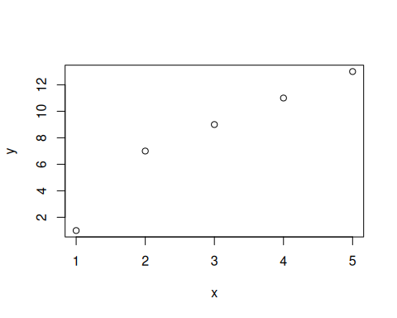
plot(3:10) #urutan
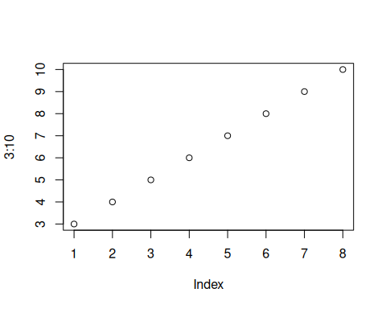
plot(3:10, type = "l")
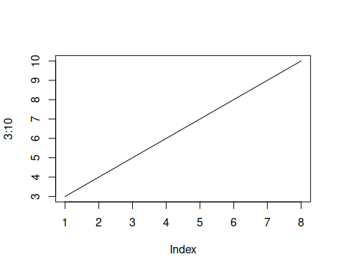
plot(3:10, main= "diagram grafik lurus", xlab = "ini adalah sumbu X", ylab = "sumbu Y", type = "l")
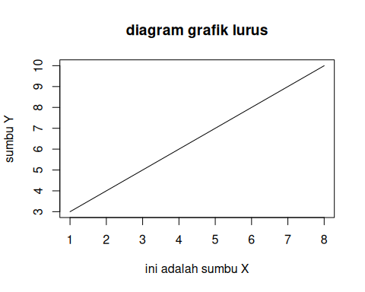
plot(1:10)
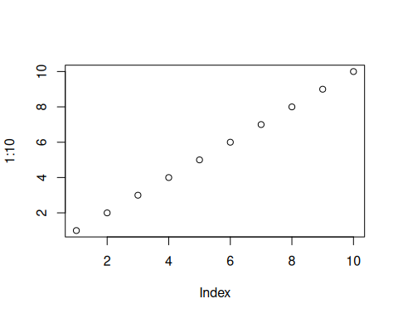
plot(1:10, pch = 9)
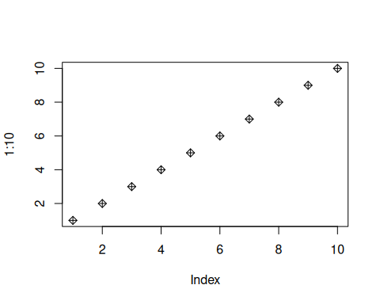
plot(1:10, pch = 10, type = "l")
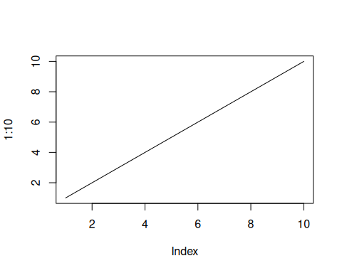
plot(1:10, pch = 11, type = "l", lwd = 11)
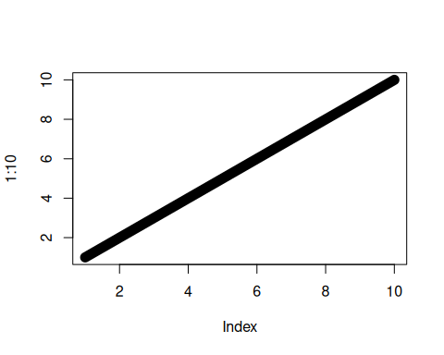
#x <- c(1,2,3,4,5)
#y <- c(1,7,9,11,13)
#plot(x, type = "l", col = "green")
#line(y, type = "1", col = "blue")

